How does fluorescent labeling affect the binding kinetics of proteins with cells?
Linliang Yin^{1,2}, Wei Wang^{3 *}, Shaopeng Wang², Fenni Zhang², Shengtao Zhang^{1 *}, and Nongjian Tao^{2,3 *}
1 College of Chemistry and Chemical Engineering, Chongqing University, Chongqing 400044, China
2 Center for Bioelectronics and Biosensors, Biodesign Institute, Arizona State University, Tempe, AZ 85287, USA
3 State Key Laboratory of Analytical Chemistry for Life Science, School of Chemistry and Chemical Engineering, Nanjing University, Nanjing 210093, China

*Corresponding authors:
Wei Wang wei.wang@nju.edu.cn
Shengtao Zhang stzhang@cqu.edu.cn
NJ Tao njtao@asu.edu

1. Information for materials and experimental methods.
1.1 Cell culture: SH-EP1 cells were cultured in an incubator at 37 °C with 5% CO₂ and 70% relative humidity. Dubelco’s Modified Eagle’s Medium (DMEM, Invitrogen, Carlsbad, CA) with 10% Fetal Bovine Serum (FBS, Invitrogen) and penicillin-streptomycin (BioWhittaker, Basel, Switzerland) were used as culture media. When the cells reach the confluent of approximately 80%, they were passaged with 0.05% trypsin and 0.02% EDTA in Hank’s balanced salt solution (HBSS, Sigma-Aldrich, St. Louis, MO).
1.2 Surface plasmon resonance (SPRi) setups. In the prism-based SPRi set-up, p-polarized light from a 670 nm light-emitting diode (LED, L7868-01, Hamamatsu, Japan) was directed through a SF-11 prism onto the gold-coated BK-7 glass coverslip placed on the prism. The LED light source was mounted on a temperature-controlled mounting socket (LDM21, Thorlabs, Newton, NJ). In the objective-based SPRi configurations, a fiber-coupled 680 nm super luminescent diode (Qphotonics LLC, Ann Arbor, MI) was used as light source of an inverted microscope (Olympus IX81, Japan) with a total internal reflection fluorescence imaging attachment. A 60X high numerical aperture objective (N.A.=1.49) was used to excite the surface plasmon. In both configurations, the reflected beam produced an SPR image. which was captured by a CCD camera (Pike F032B, Allied Vision Technologies, Newburyport, MA).
The sensor chips were BK-7 glass coverslips coated with 2~3 nm chromium followed with ~47nm gold fabricated by thermal evaporator in high vacuum (3×10⁻⁶Torr). A Flexi-Perm silicon chamber (SARSTEDT) was placed on top of the gold chip serving as a cell culture well. To promote strong cell adhesion to the gold surface, the chips was pretreated with 75 µL of 10 µg/mL collagen solution. About 5000 cells in 250 µL growth media were added into the chamber. The wells were kept in the incubator for 24 hours to allow the attachment and growth of cells. Prior to SPRi experiments, the adhered cells were rinsed by PBS buffer, and then fixed by 4% paraformaldehyde solution.
2. Net charge calculation: The Net-Charge was calculated according to the electronic theory of acids and bases. The acidic groups in each fluorescent molecule studied here dissociate in aqueous solution, and the molecule becomes partially charged. For the first order acid dissociation reaction, the net charge ($ρ$) of the molecule is given by
(S1)
where z_{i} and K_{A} (i) are the charge number and acid dissociation constant of the i^{th} acidic group, and [H⁺] is the concentration of hydrogen ion, H⁺, in the solution. In this study, the pH of the buffer was 7.4, and the K_{A} value of each functional group in the dye molecules was obtained from literature (D.H. Ripin et al., 2014). The net charge for each dye molecule was obtained and listed in Table S1.
Table S1: Calculations of net charge for fluorescent molecules
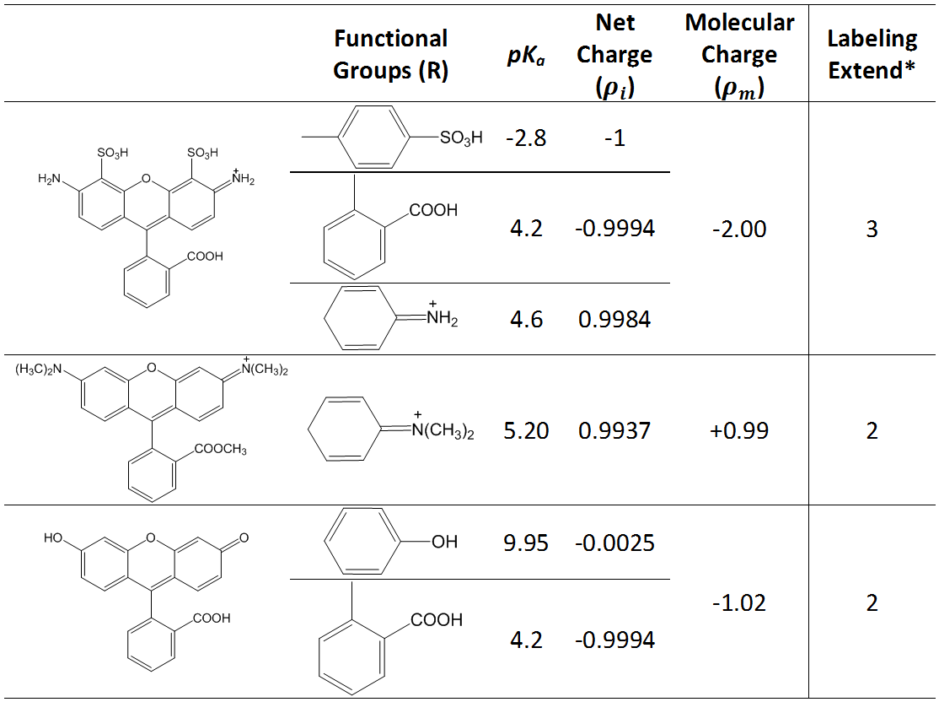
*Unit: mol fluorescent labels per mol protein. (From the product information on Certificates of Analysis)
3. Regeneration of GlcNAc on cell membrane: After completing one cycle of association and dissociation studies, we regenerated the cell membrane surface. The regeneration was achieved by injecting 50 mM GlcNAc solution for 100s, which removed WGA from the cell surface via competitive interaction of surface-bound WGA and high concentration GlcNAc. This GlcNAc treatment completely regenerated the glycoproteins on cell surface and did not affect further WGA-glycoprotein binding. Figure S1 plots the SPR sensorgrams of un-labeled WGA before and after regeneration, showing the excellent performance of the regeneration procedure. We also demonstrated that the surface regeneration with GlcNAc was highly effective without altering the binding sites on the cells for at least five cycles (Wang et al., 2012).
Figure S1: Repeatable binding signal of WGA with glycoproteins on the cells before and after the regeneration
4. Two-component model: We used a two-component model consisting of a fast binding process and a slow one, to describe the binding kinetics of WGA to the sugar units of the cell membrane. For the fast process, the association phase is given by
${R_{1}(t)=R}_{1}[1-e^{-\left(k_{a1}*C+k_{d1}\right)t}]$, (S2)
and the dissociation phase is given by
$R_{1}(t)=R_{1}*e^{-k_{d1}(t-t_{0})}$, (S3)
where R₁ is the bound WGA at the end of association, k_{a1} and k_{d1} are the association and the dissociation rate constants, respectively, C is the concentration of flowing WGA, t is the elapsed time for measurement and t₀ is the time period for association.
The binding affinity (K_{D1}) can be calculated by
$K_{D1}={k_{d1}}/{k_{a1}}$ . (S4)
Similarly we have the expressions for the slow process, and given by,
${R_{2}(t)=R}_{2}[1-e^{-\left(k_{a2}*C+k_{d2}\right)t}]$, (S5)
$R_{2}(t)=R_{2}*e^{-k_{d2}(t-t_{0})}$, (S6)
and
$K_{D2}={k_{d2}}/{k_{a2}}$ (S7)
for the association and dissociation processes, and binding affinity, respectively.
This model provides excellent fitting to the sensorgrams of un-labeled and fluorescent-labeled WGA binding to GlcNAc on cell membrane as shown in Figures S2a-d. The kinetics parameters derived from the model are listed in Table S2.
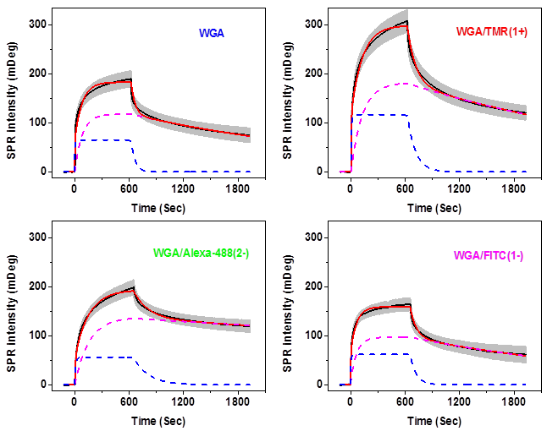
Figure S2: Two-component kinetics model fitting for (a) unlabeled WGA, (b) WGA/TMR(1+), (c) WGA/Alexa-488(2-) and (d) WGA/FITC(1-) GlcNAc on the cell membrane. Fifty cells were examined for each case and variations were shown in grey background. The black and the red curves are original sensorgrams and fitted ones, respectively. The magenta dash line represented the slowing binding process and the blue one is for the fast binding process.
Table S2. Kinetics parameters derived from the two-component kinetics model
for un-labeled and fluorescent-labeled WGA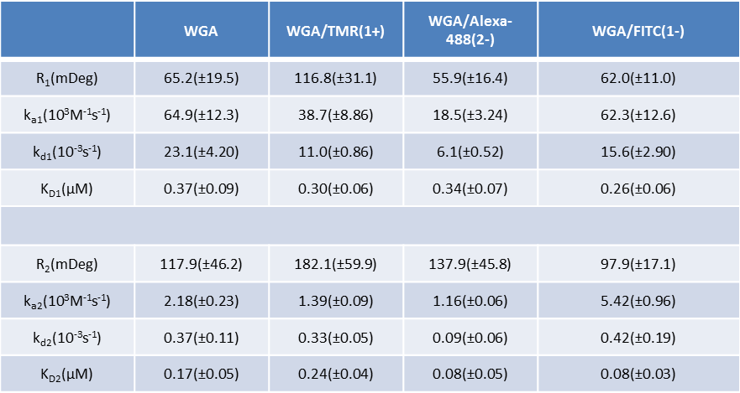
5. Effect of fluorescent labels on the spatial binding distribution. The experimental procedure is shown in Fig. S3a, we introduced the unlabeled WGA at first to determine the local distribution of target membrane protein on the cells. Then the cell surface was regenerated by high concentration GlcNAc solution via competitive interaction. Afterwards, sequential repetition with WGA/Alexa-488(2-) and WGA/TMR(1+) allowed us obtain the spatial binding distribution of fluorescent labeled WGA on the same cells. Finally, the unlabeled WGA was re-introduced to check the stability of membrane proteins on the cell surface after multiple cycles of binding-regeneration. Figs. S3b and S3c are bright field and SPR images of the same individual cells, respectively. Figures 3d-f show distribution maps of unlabeled WGA, WGA/Alexa-488(2-) and WGA/TMR(1+), respectively. Each distribution map was obtained by subtracting the SPR image before association from that at the end of dissociation. It is clear from Figs. 3d-f that the distribution maps obtained with unlabeled WGA, WGA/Alexa-488(2-) and WGA/TMR(1+) are significantly different at certain subcellular locations, especially where indicated by black arrows. Fig. S3g shows the binding map of unlabeled WGA after all experiments, which keeps the same distribution and intensity as the one before binding-regeneration cycles (Fig. S3d), demonstrating that the target proteins are stable on the cell membrane. This suggests that the alteration of binding distributions is indeed from probe proteins, which is highly properly due to the net charge of the labeled dyes.

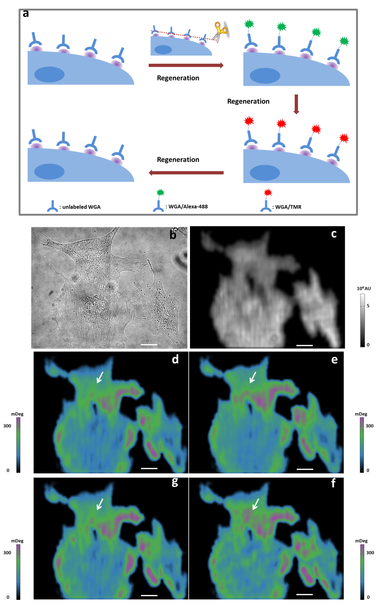
Figure S3: Effects of fluorescent labels on local distribution of bound proteins. (a) Experimental procedure. The unlabeled WGA was introduced to bind with the glycoproteins at first. After the whole association and dissociation processes were obtained, the cell surface was regenerated for another binding cycle. Sequential repetition with WGA/Alexa-488(2-) and WGA/TMR(1+) enables to analyze the binding localizations of different probe proteins on the same cells. At last, the unlabeled WGA was re-introduced to check the stability of the target proteins on the cell membrane. (b) Bright field and (c) SPR images of SH-EP1 cells. The binding maps for (d) unlabeled WGA, (e) WGA/Alexa-488(2-) and (f) WGA/TMR(1+). These maps were generated by subtracting the baseline image from the one at the end of dissociation. (g) The binding map of unlabeled WGA after several binding-regeneration cycles, which demonstrates the efficiency of the regeneration and the stability of the target proteins. (Scale bar: 10µm)

6. Dependence of binding kinetics on ionic strength for WGA/FITC(1-)
Figure S4 The sensorgrams of WGA/Alexa-FITC(1-) interacting with glycoproteins
on cell membrane surfaces in 0.5xPBS, 1xPBS and 2xPBS buffer.

7. Effect of ionic strength on the kinetics parameters: We also used the two-component model to fit the sensorgrams of WGA/Alexa-488(2-) and WGA/TMR(1+) binding to GlcNAc on the cell membrane in incremental ionic strength solution, that is 0.2x, 0.5x, 1x, 2xPBS. The derived value for each parameter is listed in Table S3.
Table S2: Kinetics parameters obtained from two-component model for WGA/Alexa-488(2-) and WGA/TMR(1+) in solutions with different ionic strengths

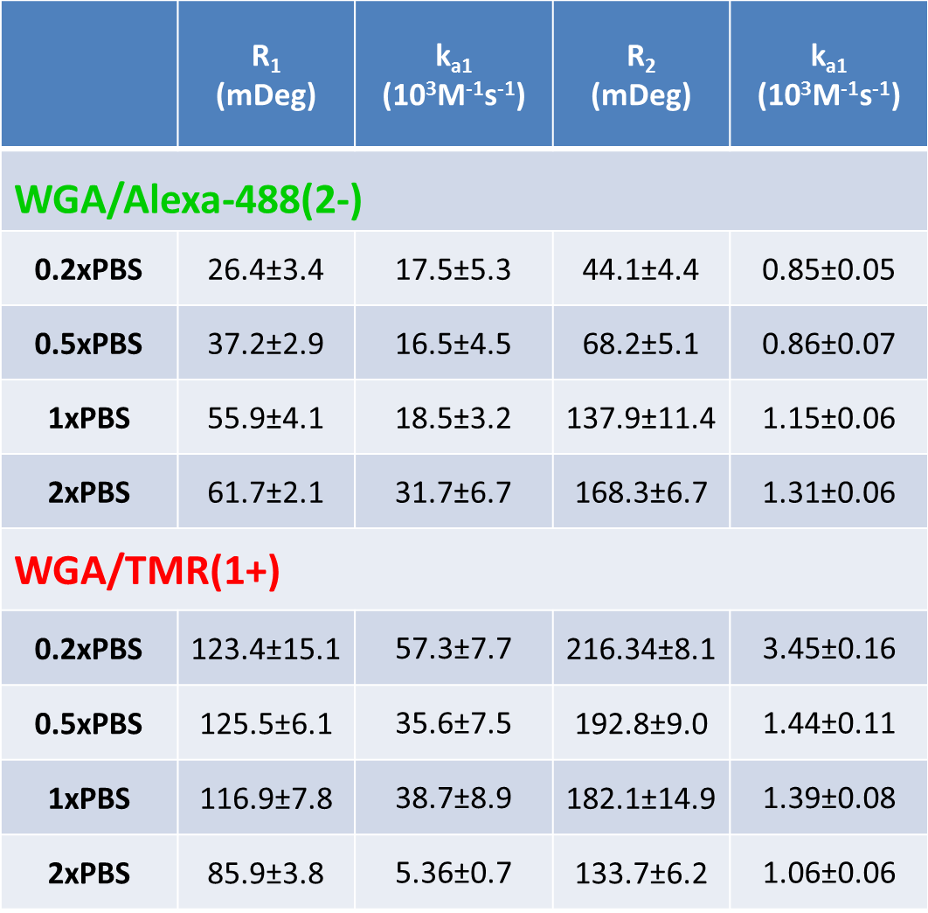
8. Effect of ionic strength on signal difference between WGA/Alexa-488(2-) and WGA/TMR(1+).
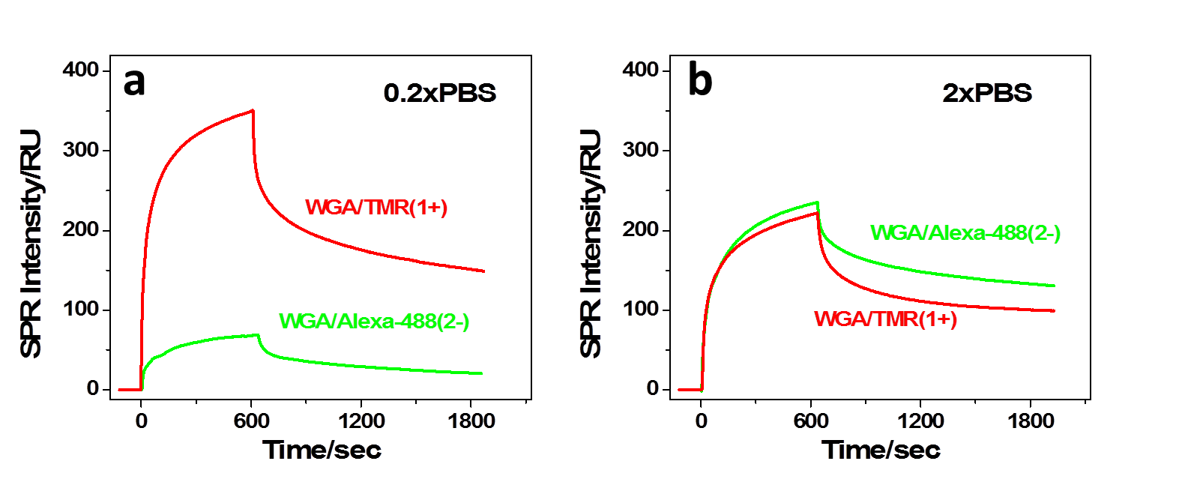
Figure S4 The signal difference betweenWGA/Alexa-488(2-) and WGA/TMR(1+) in 0.2xPBS and 2xPBS buffer.

REFRENCES
D.H. Ripin, D.A. Evans. http://evans.rc.fas.harvard.edu/pdf/evans_pKa_table.pdf (08/09/2014)
Wang, W., Yang, Y., Wang, S., Nagaraj, V.J., Liu, Q., Wu, J., Tao, N., 2012. Nat. Chem. 4, 846–853.

